Physical Education
Make-Up Project Information

Fitness refers to a condition in which an individual has sufficient energy to avoid fatigue and enjoy life. Physical fitness is divided into both health and skill related components.

Health Related Fitness Components

Health related fitness components are the aspects of fitness that enable one to remain physically healthy. They are:

1. Cardiorespiratory Endurance: The ability of the heart and lungs to provide
oxygen rich blood to the muscles during physical activity for a prolonged period
of time. This requires a strong heart, healthy lungs, and clear blood vessels.
Activities to improve fitness in this area would include those such as running,
swimming and cycling. The mile or PACER are measures of this fitness
component.

2. Muscular Strength: The ability of a muscle to exert a maximal force over a
short period of time (ie. how much weight can you lift?) We measure this fitness
component with the push-up test.

3. Muscular Endruance: The ability of a muscle to sustain repeated
contractions over an extended period of time (ie. muscles can perform a
movement again and again without getting tired). We measure muscular
endurance with the sit-up test.

4. Flexibility: The range of motion permitted around a joint or series of joints.
You are flexible when the muscles are long enough and joints (where two bones
meet) are free enough to allow a large amount of movement. We measure
flexibility of the hamstrings and low back using the sit and reach test.

5. Body Composition: The percentage of body fat in comparison to lean
muscle tissue (ie. how much of your body is composed of fat vs bone and
muscle). People who have an excessively high amount of body fat are more
prone to the development of adult onset diseases like diabetes, heart disease
and certain types of cancers. Your body composition can be measured using
skinfold calipers, hydrostatic weighing or electrical impedance methods. Your
doctor may also asses this using BMI or Body Mass Index which uses your
height and weight to determine if you are in a healthy zone.

Skill Related Fitness Components

These components (or parts) of fitness involve skills that will enhance one’s performance in athletic or sports events. They are:

1. Agility: The ability to change and control the direction and position of the
body while maintaining a constant, rapid motion. For example, changing
directions quickly to avoid being tackled in football.

2. Balance: The ability to control or stabilize the body (distribute body weight
equally under a variety of conditions) when still or moving. For example, riding a
bike without falling over.

3. Coordination: The ability to use the senses together with body parts during
movement (ie. body parts work together to perform a task). For example,
dribbling a basketball. Using the hands and eyes together is called hand-eye
coordination.

4. Speed: The amount of distance one can travel over a period of time. For
example, running a 100M dash in 10 seconds.

5. Power: The product of force x speed. The vertical jump is an example of
how much force you can produce quickly (ie. jumping to spike a volleyball or to
dunk a basketball).

6. Reaction Time: The time that passes between a stimulus and a response
(an action and a reaction...for example, a batter hits a ball and you react to field
it.)

All of the above components of fitness can be improved by applying the concepts of:

1. Specificity: to improve a component of skill...you need to work on that
component or skill.

2. Overload: You must place greater stress on the body than it is normally
accustomed, as the body will adapt to the new and greater demands placed upon
it.

3. Progression: The overload (or stresses placed on the body) must be
gradual (over a period of time). For example, running for 10 minutes for a
week...then 15...then 20 etc.

To accomplish Specificity, Overload, and Progression...you must use the F.I.T. principle.

F = Frequency (How often you exercise...every day?)
I = Intensity (How hard you exercise...in your target heart rate zone?)
T = Time (How long you exercise...30 min?)

What should this look like for your age group?

- About 60 minutes everyday so that you are breathing heavy and your heart is beating rapidly. The 60 minutes does not have to be consecutive...it can be 20 minutes in PE, 10 at recess, 30 at home etc.

Anatomy Identification (Muscles)

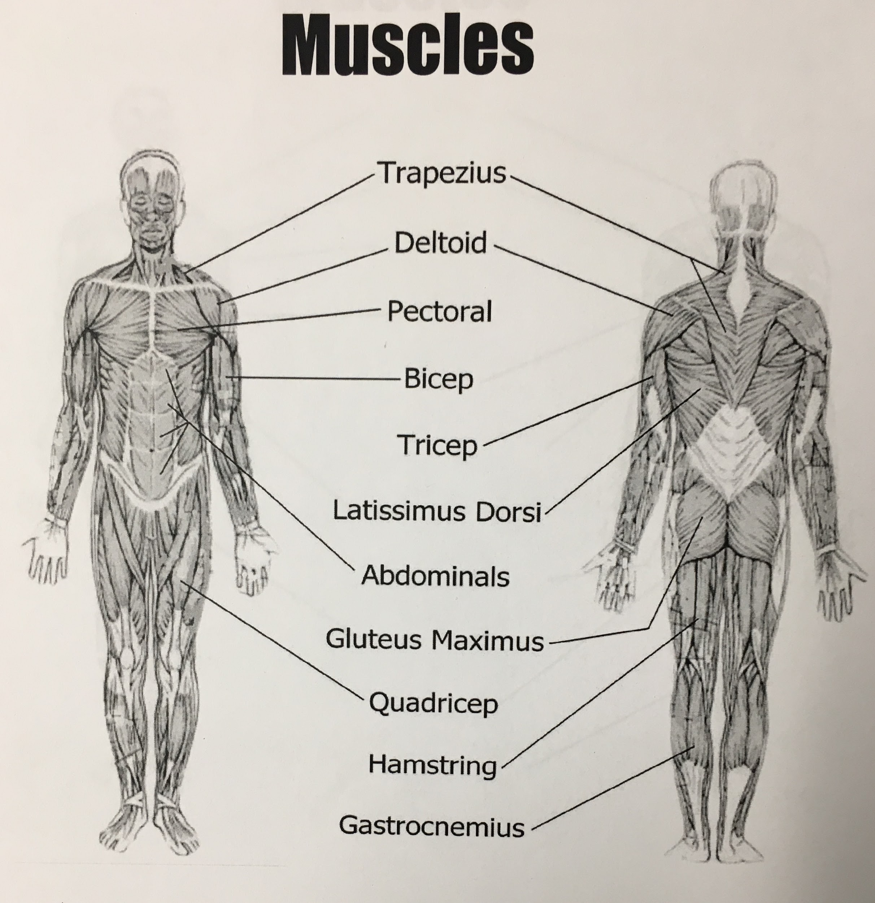

Anatomy Identification: Bones
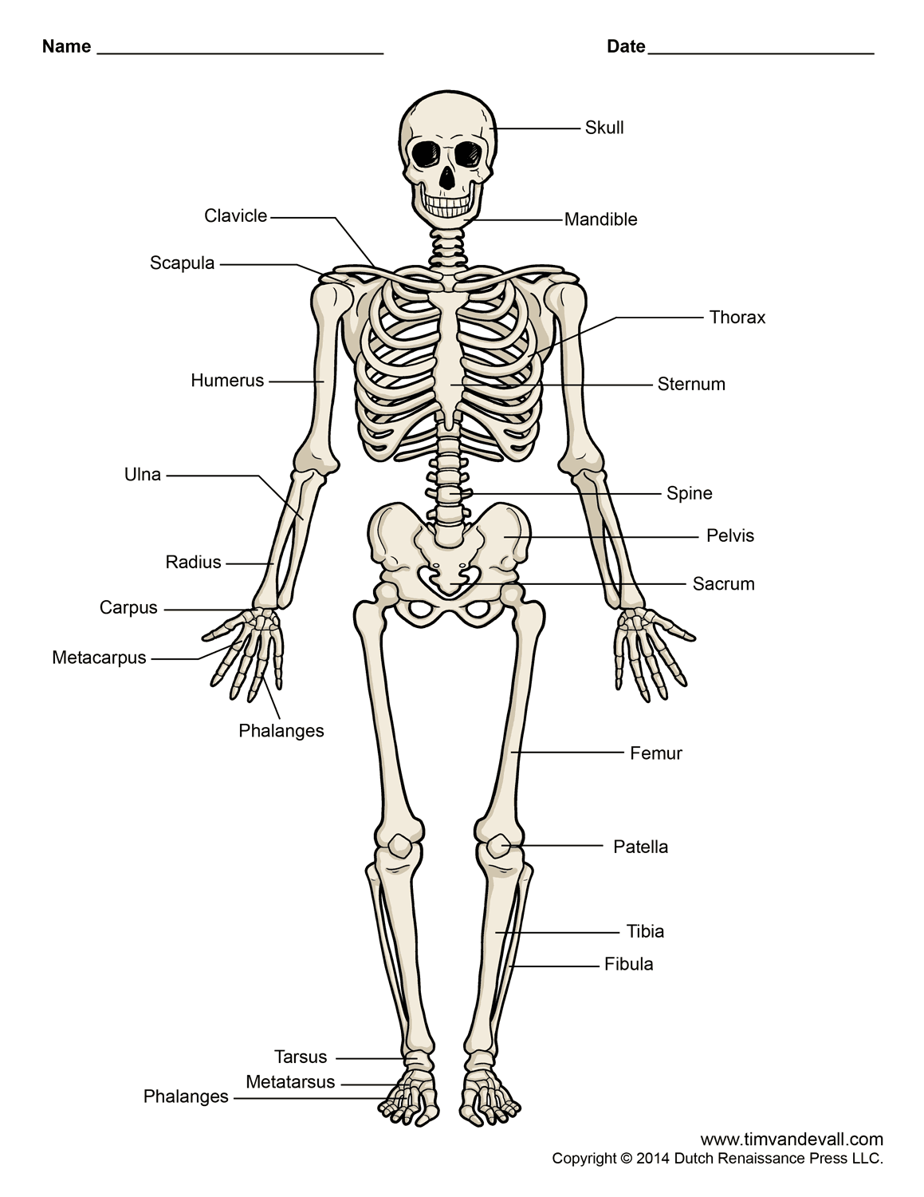

Benefits of a Physically Active Lifestyle: (There are many...here are a few!)

- Reduces the risk of developing adult onset diseases like diabetes, cancer and heart disease.
- Helps to reduce blood pressure in those who have high blood pressure.
- Helps with weight management.
- Reduces feelings of anxiety and depression.
- Helps build and maintain healthy bones.
- Enhances the immune system.
- Increases self-confidence and self-esteem.
- Gives you more energy.
- Builds strength.
- Lowers resting heart rate.
- Improves coordination and balance.
- Reduces tension and stress.
- Improves the quality of sleep.

