Name: ______________________________ Date: ________

Ray Middle School
Physical Education Make-Up Project

Physical Fitness

Directions: Complete the following packet using any and all resources you can find. This information is available on the PE webpage. To access the web page document:

- Go to: http://raymiddlepe.weebly.com/
- Click on PE Make-up Assignment

Physical Fitness refers to a condition in which an individual has sufficient energy to avoid fatigue and enjoy life. Physical fitness is divided into both health and skill related components.

Identify both the health and skill related fitness components on the diagram below:

Health Related

Skill
Related

The above listed physical fitness components are developed by using the principles of:
(Fill in the blanks in the boxes below)

S____________
O_____________
P_______________
You can improve the above through changes in _____, _____, & _____.
F_____________
I_______________
T_______________

Use the terms below to correctly fill in the blanks.

1. ______________________________ refers to the ability of the heart and lungs
to provide oxygen rich blood to the muscles during physical activity for a
prolonged period of time.

2. ______________________________ refers to the range of motion permitted
around a joint or series of joints.

3. ______________________________ refers to the ability of a muscle to exert a
maximal force over a short period of time.

4. ______________________________ refers to the percentage of body fat in
comparison to lean muscle tissue (ie. how much of your body is composed of fat
vs bone and muscle).

5. ______________________________ refers to the ability of a muscle to sustain
repeated contractions over an extended period of time.

6. ______________________________ are the aspects of fitness that enable one
to remain physically healthy.

7. ______________________________ .involve skills that will enhance one’s
performance in athletic or sports events.

8. ______________________________ refers to the ability to change and control
the direction and position of the body while maintaining a constant, rapid motion.

9. ______________________________ refers to the time that passes between a
stimulus and a response.

10. ______________________________ ability to control or stabilize the body
(distribute body weight equally under a variety of conditions) when still or
Moving.

11. ______________________________ is the product of force x speed.

12. ______________________________ refers to the ability to use the senses
together with body parts during movement (ie. body parts work together to
perform a task).

13. ______________________________ refers to the amount of distance one can
travel over a period of time.

Terminology:
Health Related Fitness Components Skill Related Fitness Components Speed
Cardiorespiratory Endurance Muscular Strength Power
Flexibility Body Composition Agility Muscular Endurance Coordination Balance Reaction Time

Anatomy Identification: Fill in the blanks to identify each bone on the diagram.
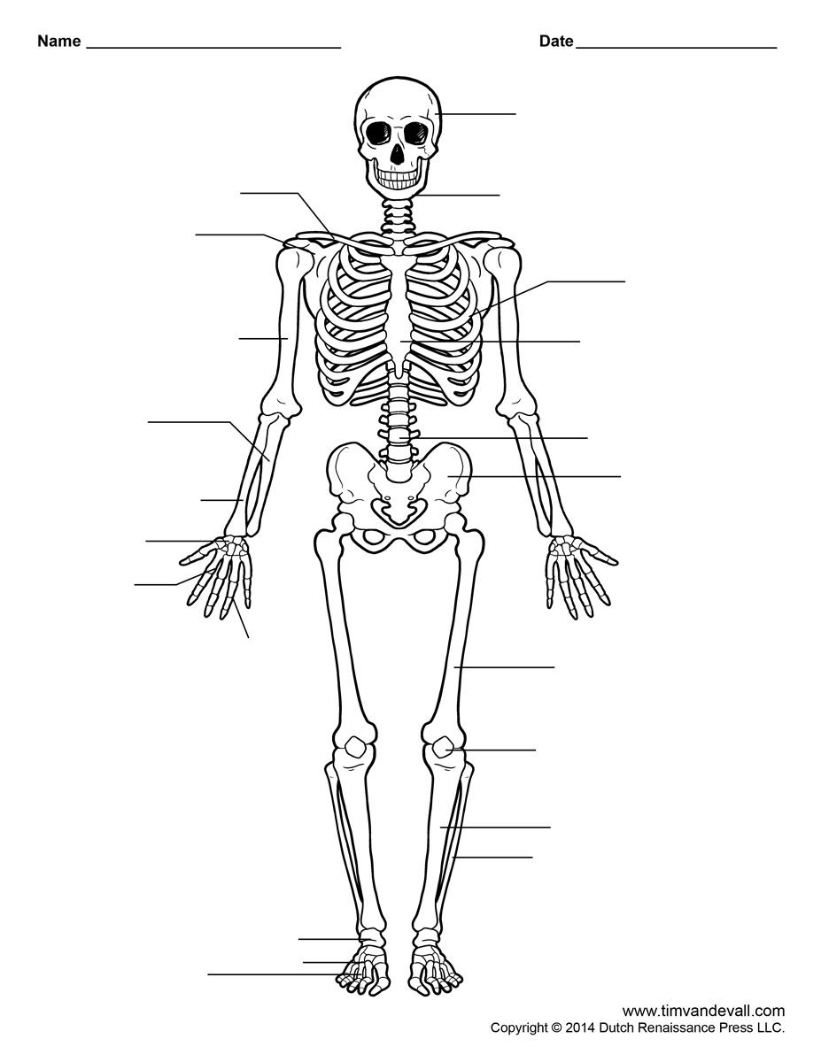

Fill in the blanks to identify each muscle group in the diagram.

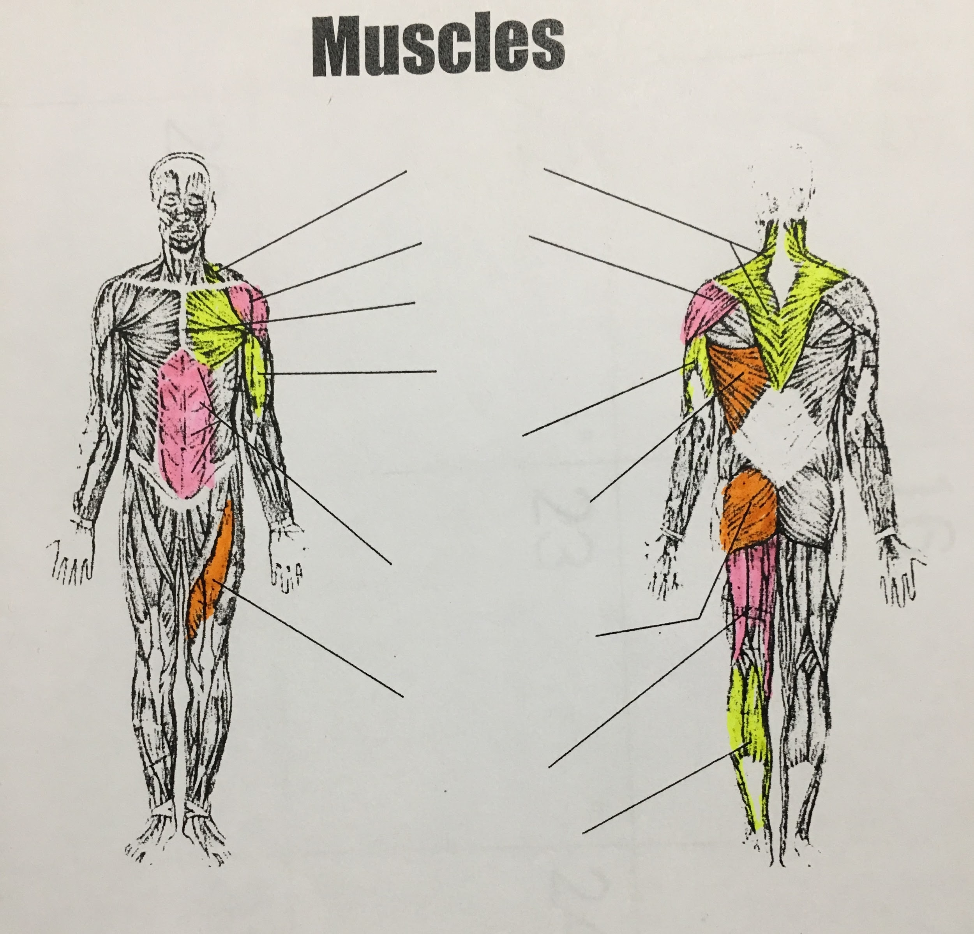

List 10 benefits of a physically active lifestyle:

1.

2.

3.

4.

5.

6.

7.

8.

9.

10.

